**DS620 Machine Learning and Deep Learning**

**HOS00 Setting up the development environment**

12/21/2020 Developed by Shanshan Yu

03/19/2021 Modified by Minh Nguyen

School of Technology and Computing (STC) @City University of Seattle (CityU)

**Before You Start**

* The directory path shown in screenshots may be different from yours.
* The document uses Google Colaborary as the default compiler. If you want to run the code on a local machine. You need to configure the environment on your own.
* Some steps are not explained in the tutorial**.** If you are not sure what to do:
  1. Consult the resources listed below.
  2. If you cannot solve the problem after a few tries, ask a TA for help.

**Learning Outcomes**

Students will be able to:

* Setup sklearn on your local machine
* Learn how to use Colab

**Resources**

* Scikit-learn: <https://scikit-learn.org/stable/index.html>
* Scikit-learn installation: <https://scikit-learn.org/stable/developers/advanced_installation.html#install-bleeding-edge>

1. **Install Scikit-learn**

**Pre-requirement:**

* Python 3.5 – 3.8
* pip version >19
* macOS 10.12.5(Sierra) or later
* Windows 7 or later (with C++ redistributes)

**Installation:**

Open Visual Studio Code → Terminal → New Terminal

In the terminal window, type the command:

pip install sklearn



Note: If you meet an error that the system can’t detect pip as a command.

If you still cannot install TensorFlow on your local computer, you can go to the next part Get start with Colabrary and use the tool to finish your assignment. Colab is a google cloud platform notebook and it doesn’t require any installation and configuration.

1. **Get start with Colaborary**

Colaborary (Colab) is a Jupyter notebook-like notebook on Google Cloud. It allows you to write and execute Python in your browser without setting up an environment. Colob provides free access to GPU and TPU, which can hugely accelerate the training speed. Training machine learning model on GPU or TPU is 5 ~ 10 times faster than training it on the CPU. If you are using an old computer with limited memory and computing power, Colab can accelerate your work.

1) Go to <https://colab.research.google.com>. You need a google account to create a new notebook.

2) Click NEW NOTEBOOK at the right down corner. It will generate a blank ipynb in your Google drive. Double click the untitle.ipynb, and change the notebook title to HelloColab.ipynb

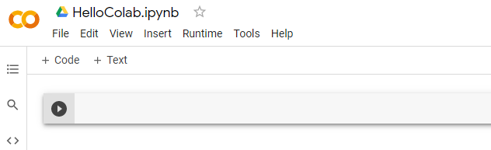

Type the following in the first cell then click the play button  or Ctrl + Enter to run the cell.

Output:



3) Add a text cell by clicking the + text button or use keyboard command “b” (but make sure you “esc” the cell first). These buttons will generate a text cell in the notebook, and a text cell is as same as a text editor. Type the following in the text editor.

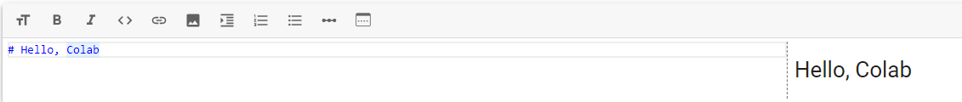

Output:

4) To download the ipynb file to your local computer for submission. Click File → Download .ipynb.

The file will be downloaded to your Download folder(or another folder according to your browser setting).

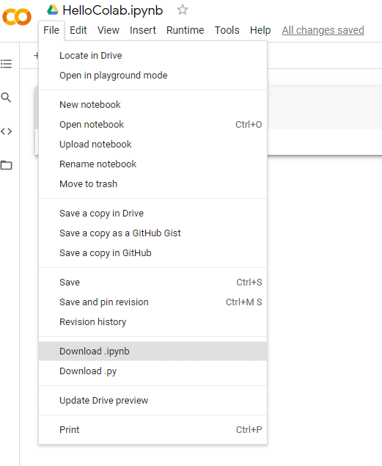

5) Select a local folder of your choice to save the file

If you want to know more details about Colab, watch the [video](https://youtu.be/inN8seMm7UI)

**3. Python Review**

Use the following resources to practice Python skills.

* Morris, C. (n.d.). Python. <https://www.kaggle.com/learn/python>
* Taulien, K. (2020). Python for Everybody: The Ultimate Python 3 Bootcamp [Video]. O'Reilly. <https://learning.oreilly.com/videos/python-for-everybody/9781800562196/> (9:20)
* Beazley, D. (2016). Python Programming Language [Video]. O'Reilly. <https://learning.oreilly.com/videos/python-programming-language/9780134217314/> (6:27)